|  |  |
| --- | --- |
| **Ex.No : 5** | **Implementation of Platform as a Service** |
| **09.05.2022** |

**Aim:**

To implement Platform as a Service using AWS EC2.

**Procedure:**

**Step 1:** Go to AWS website and create a user account.

**Step 2:** Search for AWS EC2 service in the services.

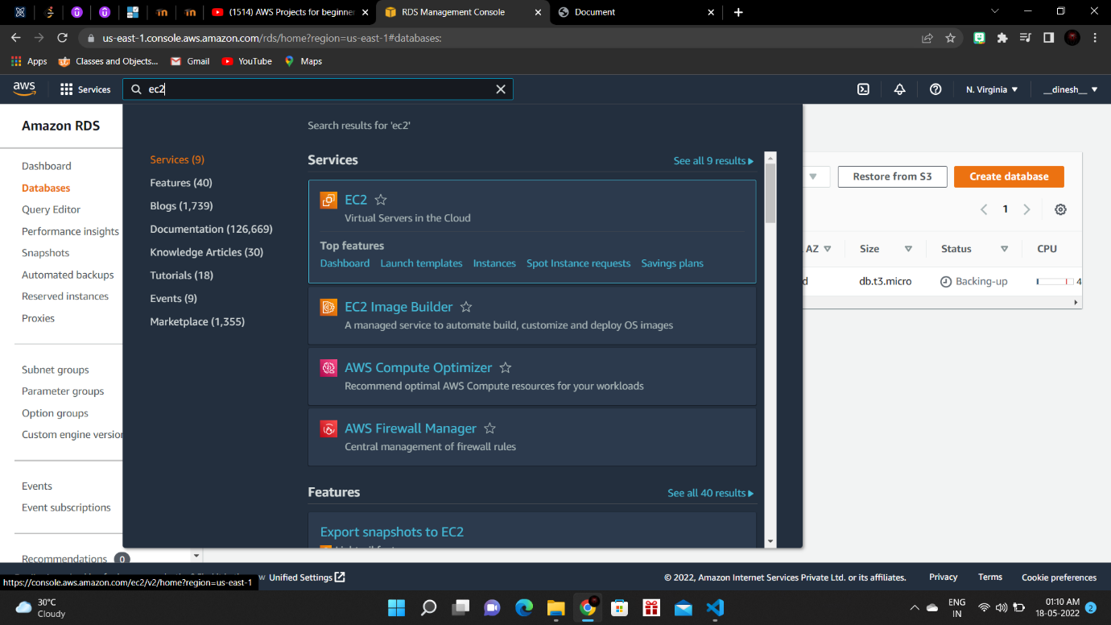

**Step 3:** Select ubuntu linux.

**Step 4:** Create a key pair which will be the private key for connecting to the virtual machine.

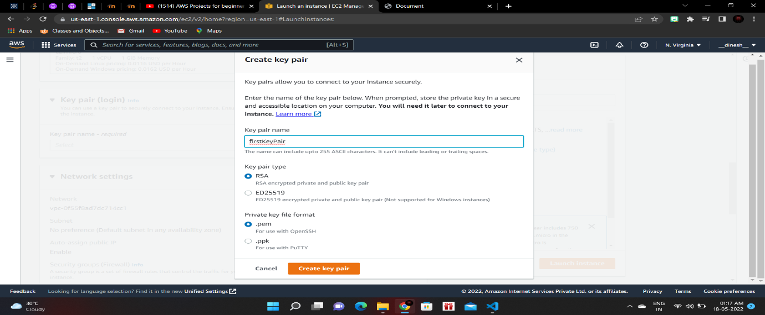

**Step 5:** Configuer the virtual machine.

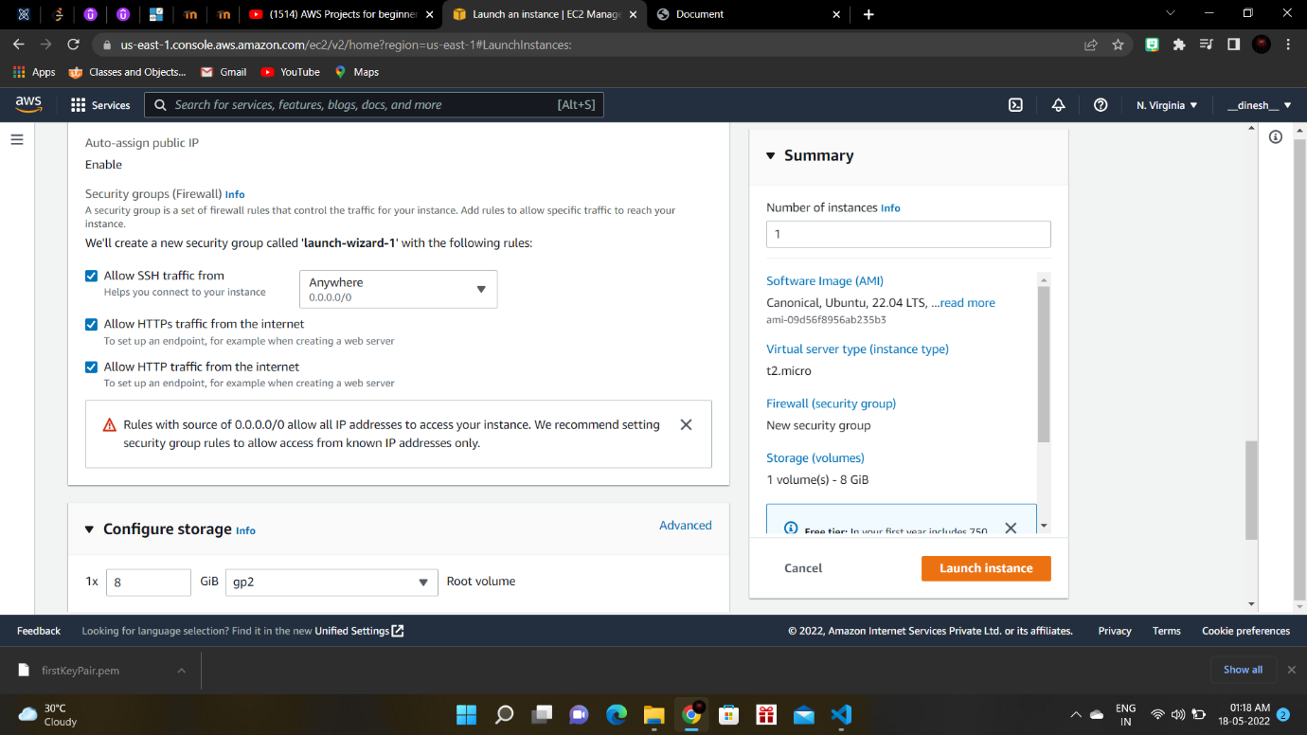

**Step 6:** Configure storage for the virtual machine.

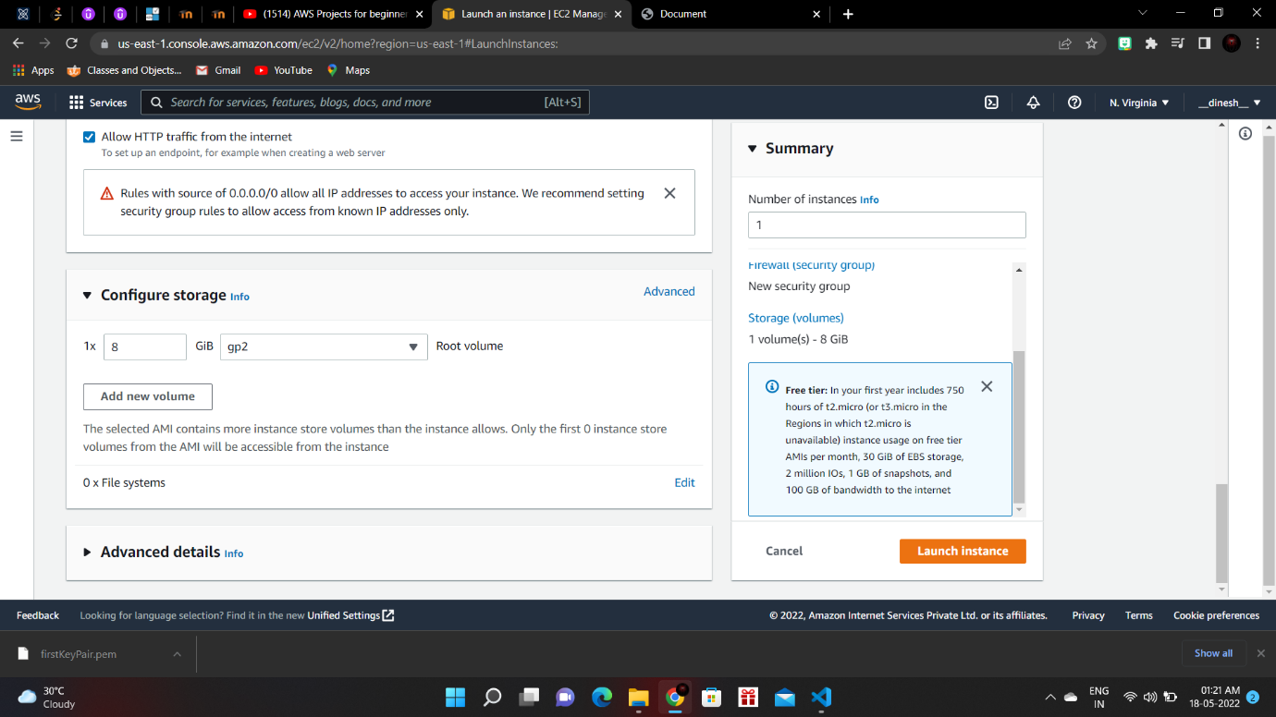

**Step 7:** The virtual machine has been successfully created on EC2.

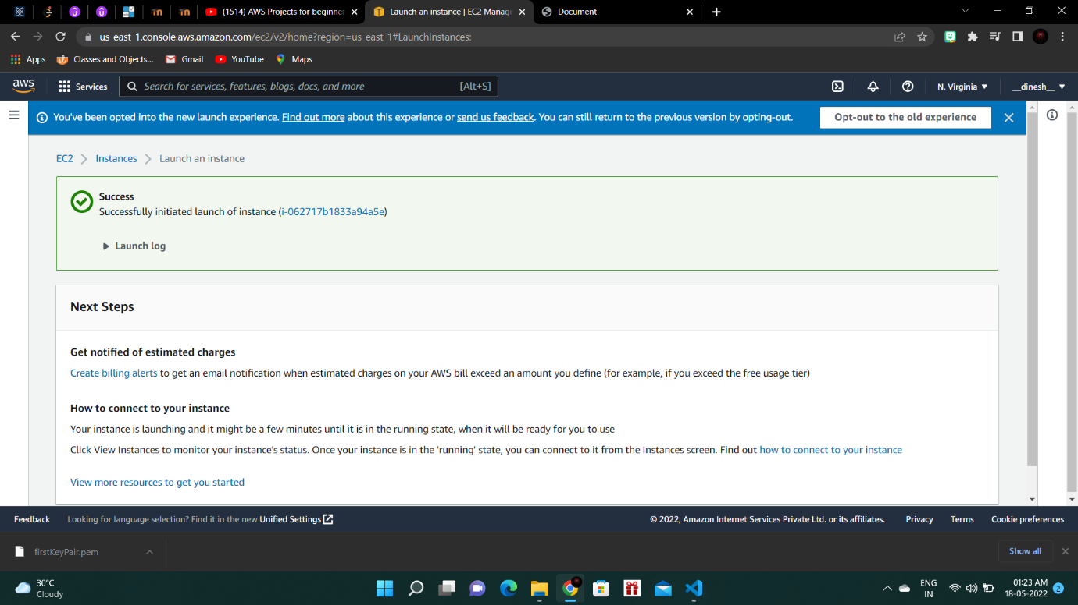

**Step 8:** The running instances will be shown in the EC2 dashboard.

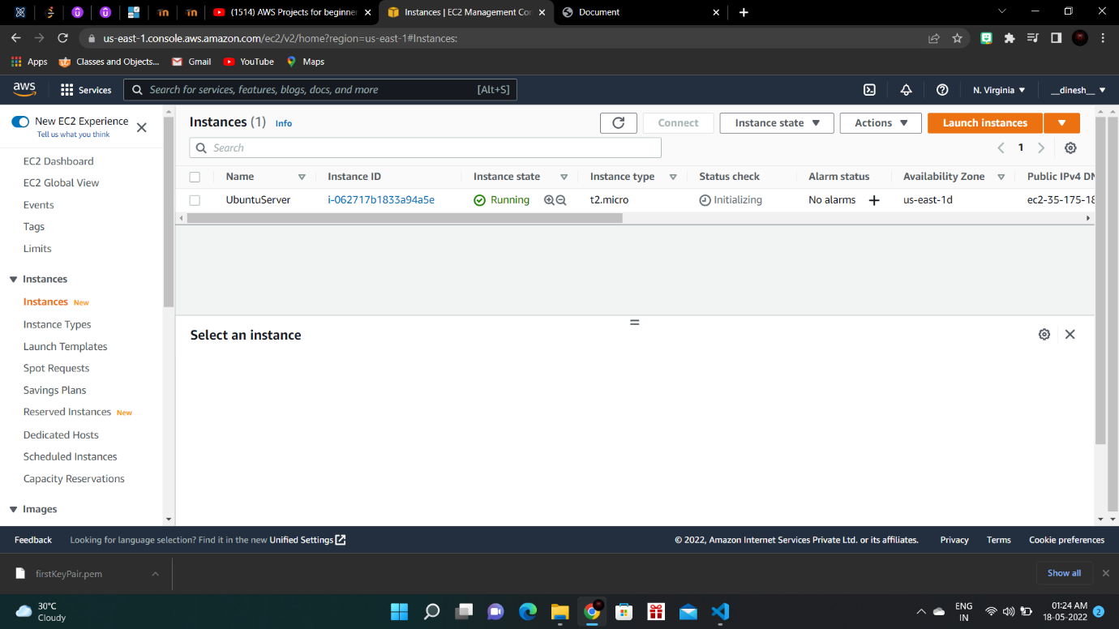

**Step 9:** Select the ubuntu server and note the public ipv4 address.

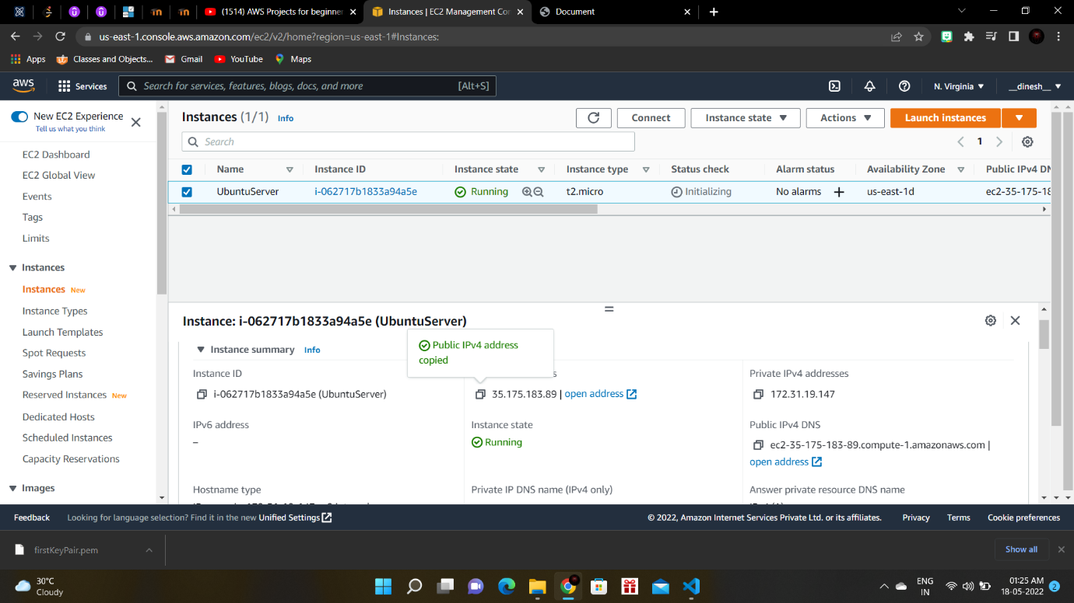

**Step 10:** Open command prompt and navigate to the folder where the key pair has been downloaded.

**Step 11:** Use “ssh -i ./<key pair file> ubuntu@<public ipv4 address>” command to connect to the ubuntu.

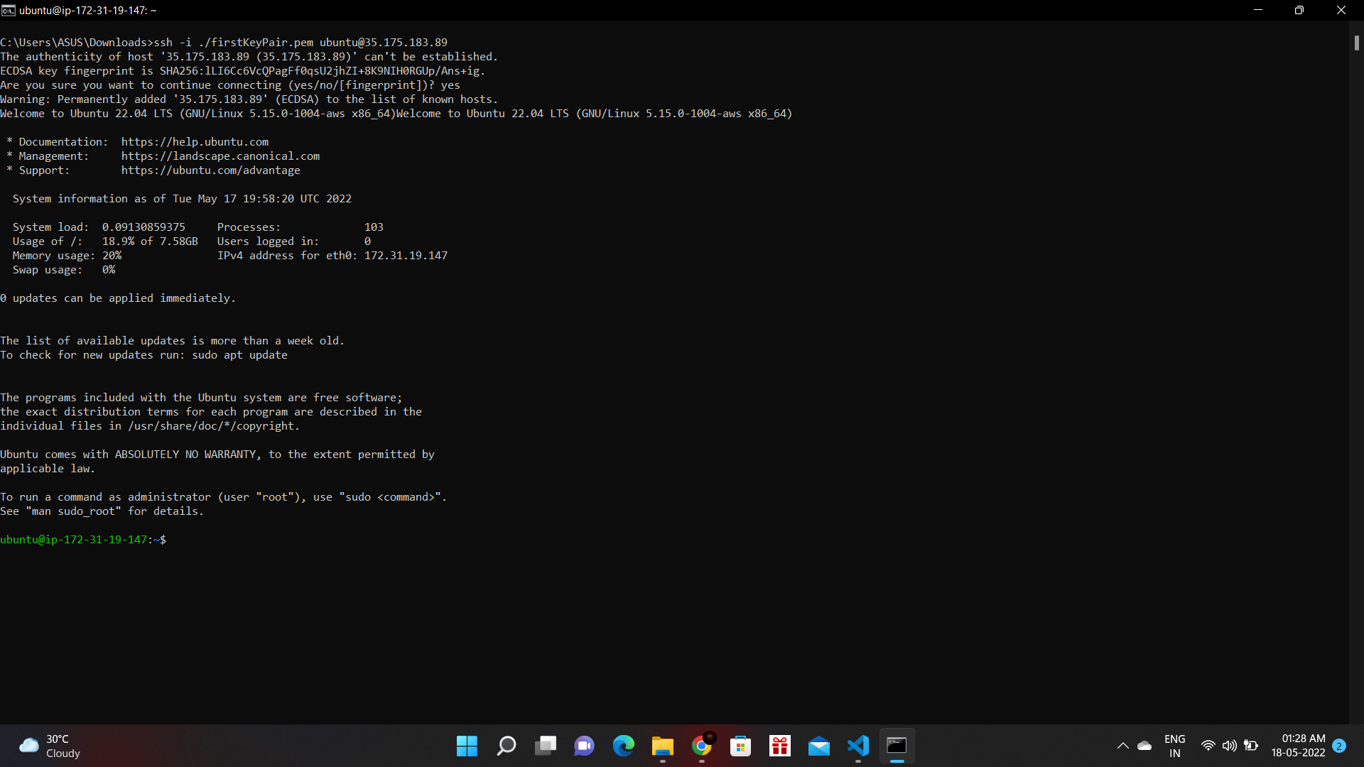

**Step 12:** Try running different linux commands in the shell.

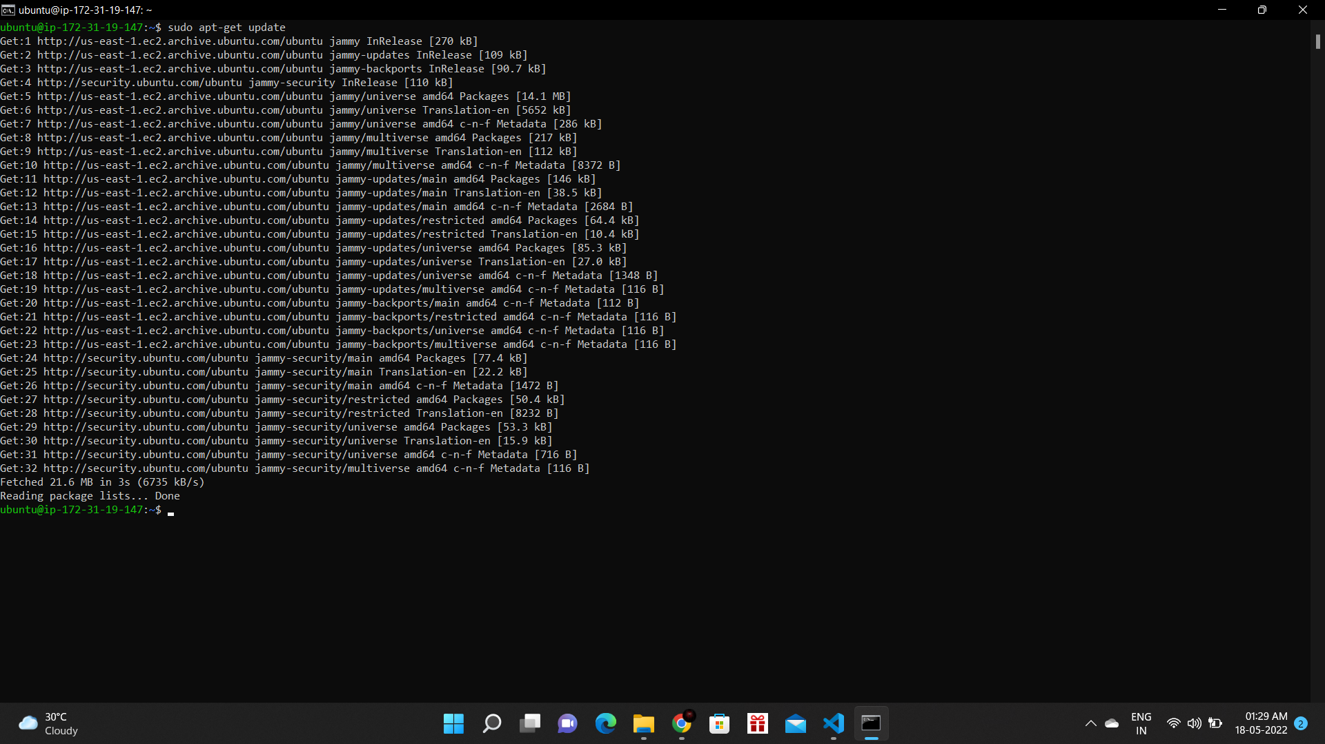

**Result:**

Thus, Platform as a service has been successfully implemented using AWS EC2.